MISSION STATEMENT:

At Rivers of Hope, our mission is to provide a sanctuary of support, instilling confidence in our individuals and families by being a beacon of hope and guiding our clients toward brighter futures through compassionate, innovative care. We are dedicated to transforming our community's health and well-being by offering personalized services and vital support. Our commitment extends to offering financial, educational, and instructional support to families aiding their loved ones.
VISION STATEMENT:

Our vision at Rivers of Hope is fostering a world where hope flows as abundantly as the rivers that inspire us
STATEMENT OF CORE VALUE:

Unity: Our success thrives on teamwork and collaboration, uniting diverse perspectives for greater outcomes.
Integrity: We build trust through responsible actions and honest relationships.
Empathy: Our approach is rooted in kindness and understanding.
Respect: Prioritizing Dignity and Civility
Diversity: We value and celebrate diversity within our staff, the people we serve, and the community.

ABOUT US:

Rivers of Hope is a Home Healthcare organization specializing in AFC, GAFC, and Home Healthcare services. We are proud to be a provider of Veterans Care.

In our AFC program, we strive for unity. Our members remain in their homes, which provides the following:
- Promote self-enhancing routines
- Rhythms of a fulfilling life
- Comfort of a home instead of a facility
- Caregivers that have a 24 x7 commitment to the Member

Is there paperwork involved? Yes, the Caregiver Log. Caregivers are required to complete their log daily and send it to us monthly.
**The caregiver must always provide Rivers of Hope’s staff with the Member and Caregiver(s)Annual Physical and bi-annual TB screening and any other vital information.

COUNTIES WE SERVE:
If you are uncertain whether we cover your area, please contact us directly.
- Plymouth, Bristol
- Norfolk, Suffolk
- Essex, Barnstable

Our dedicated, diverse team is well-educated and trained to meet your family's unique needs. We prioritize cultural competence and sensitivity, with proficiency in multiple languages, including English, Haitian Creole, Yoruba, Cape Verdean Creole, and Spanish.
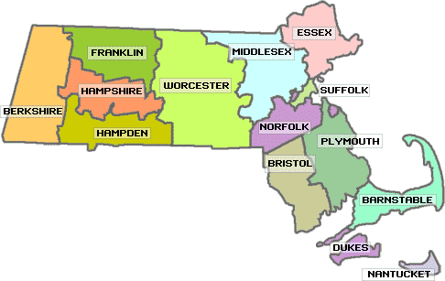
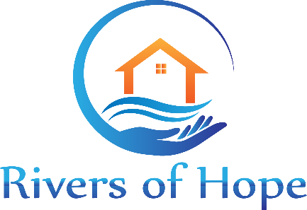

Adult Foster Care (AFC)

4 Main St, Suite 22
Brockton, MA, 02301
Office Phone: 508.857.0629
Fax: 508.857.5149
admin@riversofhopes.com www.riversofhopes.com www.facebook.com/riversofhopes www.instagram.com/rohafc
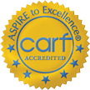
Rivers of Hope received 3 years of accreditation.

WHAT IS ADULT FOSTER CARE?

Adult Family Care (AFC), also known as AFC, is a specialized program designed to support individuals who are 16 years or older and are facing challenges due to developmental, intellectual, physical, or mental disabilities or for elderly individuals who are no longer able to safely live on their own.

In the AFC program, individuals, known as "AFC Members," reside with trained and compensated caregivers who offer round-the-clock assistance and care. These caregivers open their homes to provide a family-like living environment for AFC Members, as opposed to the traditional setting of nursing homes or other residential facilities.

Key features of Rivers of Hope's Adult Family Care program include:

- Customized Care: AFC Members receive personalized care plans that address their needs. This can encompass daily tasks such as bathing, dressing, grooming, and other forms of assistance, supervision, or cueing as required.
- Nutritious Meals and Companionship: Caregivers are responsible for providing nutritious meals, including three main meals and two healthy snacks each day. Additionally, AFC Members benefit from the companionship and emotional support provided by their caregivers.
- 24-Hour Supervision: AFC Members receive continuous supervision and support from their caregivers, ensuring their safety and well-being around the clock.
- Shared Living Arrangement: An essential component of AFC is that the caregiver and the AFC Member live together in the same household, creating a close-knit family environment.
Eligibility Requirements
Potential AFC members should:

- Be at least 16 years of age or older
- A licensed physician must order services
- Unable to live alone due to medical, physical, cognitive, or mental conditions
- Need daily assistance with one or more of the following:
Activities of Daily Living (ADL), such as
  - Bathing, Ambulation
  - Dressing (upper and lower)
  - Eating
  - Toileting
  - Mobility, Transferring
- Member and Caregiver MUST live together
- Members cannot require continuous skilled nursing
- Caregivers cannot be the spouse or legal guardian of the members

Meeting these criteria ensures eligibility and making sure the member receives essential support and care to maintain their well-being and independence at home.

ACCEPTED INSURANCE:
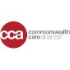

With Rivers of Hope, you can trust that you and your loved ones will receive high-quality, personalized care and support.
By choosing Rivers of Hope, you can expect the following benefits:

For Members and Their Families:
- Professional Oversight:
  - Members receive regular supervision and care assessments from healthcare professionals.
- Health and Wellness Monitoring:
  - Continuously monitor members' health and wellness
- Comfort of Home:
  - Offering a comfortable, familiar environment that enhances members' well-being.
- Personalized Care Plans:
  - Every member receives a care plan tailored specifically to their individual needs, preferences, and health conditions, ensuring personalized attention and care.
- No Cost to Members or Families:
  - Not costing the members or their families, as it is covered under specific health plans and programs.
For Caregivers:
- Monthly Stipends:
  - Caregivers receive monthly stipends as compensation for their dedication and hard work, providing financial support for their invaluable service.
- Training and Support:
  - Rivers of Hope offers comprehensive training and ongoing support to caregivers,
- Respite Care:
  - Rivers of Hope provides respite services to give caregivers

OUR ACCREDITATIONS:

