**MISSION STATEMENT:**

At Rivers of Hope, our mission is to provide a sanctuary of support, instilling confidence in our individuals and families by being a beacon of hope and guiding our clients toward brighter futures through compassionate, innovative care. We are dedicated to transforming our community's health and well-being by offering personalized services and vital support. Our commitment extends to offering financial, educational, and instructional support to families aiding their loved ones.

**VISION STATEMENT:**

Our vision at Rivers of Hope is fostering a world where hope flows as abundantly as the rivers that inspire us  
  
**STATEMENT OF CORE VALUE:**

**Unity:** Our success thrives on teamwork and collaboration, uniting diverse perspectives for greater outcomes.  
  
**Integrity:** We build trust through responsible actions and honest relationships.

**Empathy:** Our approach is rooted in kindness and understanding.  
  
**Respect:** Prioritizing Dignity and Civility

**Diversity:** We value and celebrate diversity within our staff, the people we serve, and the community.

**ABOUT US:**

Rivers of Hope is a Home Healthcare organization specializing in AFC, GAFC, and Home Healthcare services. We are proud to be a provider of Veterans Care.

Within our VA CCN service, we are dedicated to fostering unity and ensuring that our members can continue to reside in the comfort of their own homes. This approach offers several benefits, including:

* Encouraging the development of self-enhancing routines.
* Supporting the rhythms of a fulfilling life.
* Providing the comfort of home rather than a facility.
* Offering caregivers who are committed to our members 24/7.

**COUNTIES WE SERVE:**

If you are uncertain whether we cover your area, please contact us directly.

* Plymouth, Bristol
* Norfolk, Suffolk
* Essex, Barnstable

Our dedicated, diverse team is well-educated and trained to meet your family's unique needs. We prioritize cultural competence and sensitivity, with proficiency in multiple languages, including English, Haitian Creole, Yoruba, Cape Verdean Creole, and Spanish.

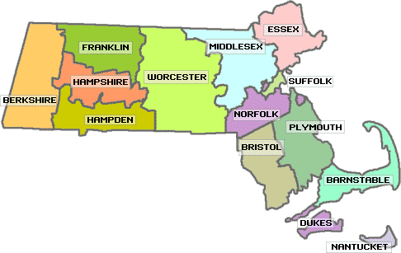

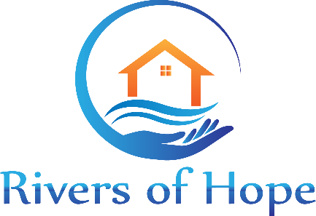

**VETERAN CARE**

[4 Main St, Suite 22](mailto:fvictoria@riversofhopes.com)

[Brockton, MA, 02301](http://www.riversofhopes.com/)

[Office Phone: 508.857.0629](http://www.facebook.com/riversofhopes)

[Fax: 508.857.5149](http://www.instagram.com/rohafc)

[admin@riversofhopes.com](mailto:admin@riversofhopes.com) [fvictoria@riversofhopes.com](mailto:fvictoria@riversofhopes.com) [www.riversofhopes.com](http://www.riversofhopes.com/) [www.facebook.com/riversofhopes](http://www.facebook.com/riversofhopes) [www.instagram.com/rohafc](http://www.instagram.com/rohafc)

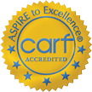

Rivers of Hope received 3 years of accreditation.

**What is the VA Community Care Network? HOW CAN WE HELP?**

The VA Community Care Network (CCN) is a program established by the U.S. Department of Veterans Affairs (VA) to ensure that eligible Veterans receive timely, high-quality healthcare services from community providers when the VA cannot provide the necessary care. It serves as a direct link between the VA and community healthcare providers to expand access to care for Veterans.

Under the CCN, eligible Veterans may receive care from approved community providers based on certain conditions and eligibility requirements. The VA typically authorizes these services before a Veteran can receive care from a community provider. The goal is to provide Veterans with greater flexibility and access to healthcare services that meet their needs and circumstances.

The CCN program helps Veterans receive the healthcare services they require, whether for primary care, specialty care, mental health services, or other medical needs, by partnering with a network of community healthcare providers.

**Rivers of Hope** is a trusted VA CCN provider committed to effectively assessing and assisting our veterans.

Our commitment to veterans is rooted in respect and dignity, honoring their sacrifices. The VA covers the cost of their care.

**TYPES OF CARE:**

Rivers of Hope is committed to providing comprehensive and compassionate home health care services to eligible Veterans, prescribed by a VA physician and guided by their expertise.

**Our home health care services encompass:**

* Skilled home health care
* Home health aide
* Homemaker
* Personal Care
* Companionship
* Respite care

**To be eligible for our home health care services, there are specific requirements that need to be met:**

1. A VA physician must order the services.
2. The Veteran must be part of the VA Community Care Network (VA CCN).
3. They should have certain medical, physical, cognitive, or mental conditions.
4. Daily assistance is needed with one or more Activities of Daily Living (ADL), including:
   1. Bathing
   2. Ambulation, Mobility
   3. Dressing (both upper and lower body)
   4. Eating
   5. Toileting
   6. Transferring

Meeting these criteria ensures eligible Veterans receive essential support and care to maintain their well-being and independence at home.

**By choosing Rivers of Hope, you can expect the following benefits:**

1. Tailored Support: We customize our services to meet each family's unique needs and preferences.
2. Qualified direct aides: Our employees are carefully selected and trained to provide exceptional care.
3. Well-Trained Staff: Our team members undergo thorough training to ensure they are equipped to provide the best care possible.
4. Multidisciplinary Team: Our team includes direct aides, Licensed Practical Nurses (LPN), and/or Registered Nurses (RNs)
5. Ongoing Training: We provide monthly training sessions during our visits, led by our Care Manager and/or RN, to continually enhance the quality of care.
6. Advocacy Support: Our team is dedicated to helping you advocate for your family member's well-being and peace of mind.

With Rivers of Hope, you can trust that you and your loved ones will receive high-quality, personalized care and support.

